## 5.5 Pressure Sensor

### 5.5.1 Fall Subsystem

To accurately simulate the occupancy functionality of the LESA Smart room, pressure sensors were implemented. These sensors are key components in helping the microprocessor detect whether an occupant has entered the model room. Once data from pressure sensor detects an occupant, The RPi will control the LED to turn on or off as well change the color. In the previous version, four individual resistive pressure sensors are positioned on a 2x2 grid on the floor of the model. This is a total resolution of 4 quadrants. The following figure shows the four different zones of four pressure sensors and relative reactions.

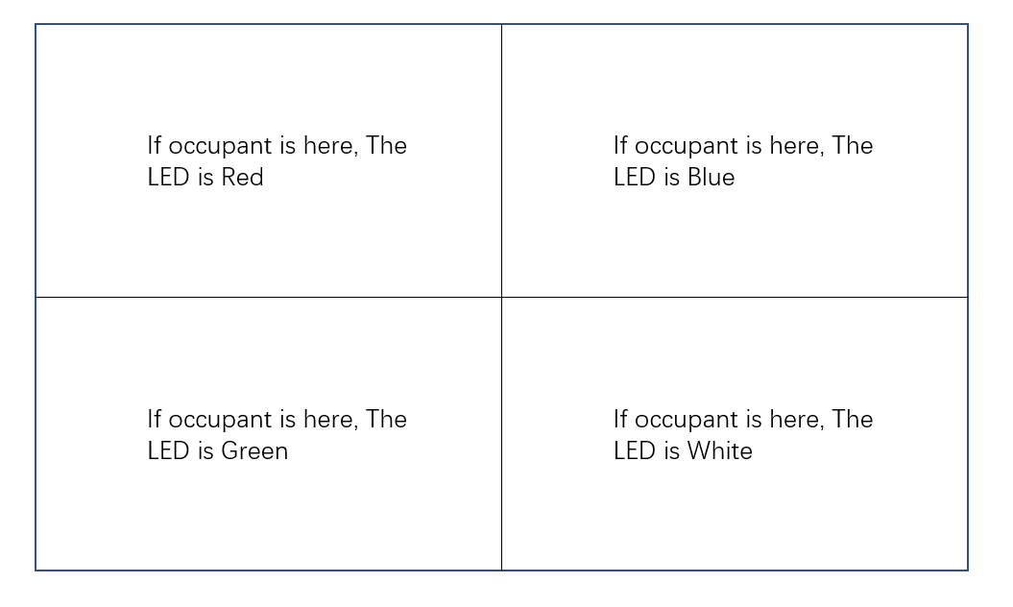

Figure 23: Placement of four quadrants and relative reactions [3]

The previous semester’s design detects basic occupancy when touch the ground of a quadrant, and can react in ways such as turning on the LED or changing the color of the LED according to which zone detects weight. Although this basic functionality is adequate, there are some issues.

First, the previous model’s sensor is covered in a plastic protective material, which is not durable and contains lumps and valley’s that may incorrectly alter data. This plastic ground is also not flat, which doesn’t accurately model the floors of the Smart Room.

Secondly, the previous model’s resolution of four may not be sufficient for accurate occupancy tracking. With the new circuit design for the Model Smart Room, the number of the input pins will be increased, which allows for the resolution to be increased as well.

Lastly, the stability of previous model is not sufficient. The bottom-left corner zone, as shown in figure 15, is not always functional. At time this quadrant cannot properly detect any occupancy. After testing, the problem was found to be in the wiring.

### 5.5.2 Subsystem Requirements

The redesigned pressure sensor must accurately detect occupancy and be intuitive enough to be assembled quickly. Based on the drawbacks of the previous model, the new pressure sensor will have following additional requirements.

1. The cover material must be replaced to ensure the pressure sensor properly models a flat floor.
2. A higher resolution is required for proper occupancy tracking. The total number of pressure zones will be increased, which will improve the accuracy of occupancy detection.
3. Simplify the model by removing redundant wiring and circuit components.
4. Portability and simple assembly

### 5.5.3 Benchmarking and Concept Selection

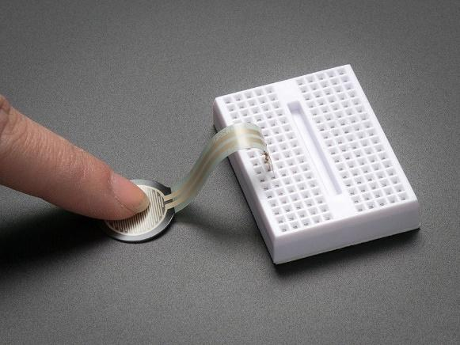

Figure 24: Premade Pressure sensor

The pressure sensors are being compared between the previous design and the current design, which increases the resolution, incorporates a flat surface, and requires less wiring. There are commercial pressure sensors available on Adafruit ( Adafruit.com, 2017) and customized sensors that are made from pressure-sensitive conductive sheets.

These two concepts are compared according to the system requirements. The following table shows the concept selection:

Table 12: Pressure Sensor Concept Selection Matrix

|  |  |  |
| --- | --- | --- |
|  | Premade Sensor | Customized Sensor |
| Size | -1 | 1 |
| Cost | -1 | 0 |
| Durable | 1 | 0 |
| Ease of use | 1 | 0 |
| Accuracy | 1 | 1 |
| **Total Point** | **1** | **2** |

Although the premade pressure sensor is more durable and easy to use, it leaves a large footprint and will not properly fit in the model smart room. The cost is also higher than the customized sensor. Due to these results, a customized sensor was seleted.

As seen in the requirements, the resolution of previous model must to be improved. The previous external A/D converter limited the total number of sensors and that could be replaced. There are some replacements that allowed for more sensors to be connected to the to the Raspberry Pi, such as A/D converter with 16 pins and integrated circuit MPR121 with more input pins.

Both circuit designs were compared according to the system requirements. The following table shows the concept selection:

Table 13: Pressure Sensor Circuit Concept Selection Matrix

|  |  |  |
| --- | --- | --- |
|  | A/D Converter with More Pins | Integrated Circuit MPR 121 |
| Size | -1 | 1 |
| Cost | 1 | 0 |
| Durable | 0 | 1 |
| Ease of use | 0 | 1 |
| Accuracy | 1 | 1 |
| Number of Allowed Sensor | 0 | 1 |
| **Total Point** | **1** | **5** |

Both devices allow for more sensors to be implemented, but the A/D converter has a larger circuit size due to more pins, which corresponds to messy wiring on the breadboard. Thus, the MPR121 Capacitive Touch Sensor is selected for this design. This sensor utilizes 12 input pins, making the higher resolution design possible.

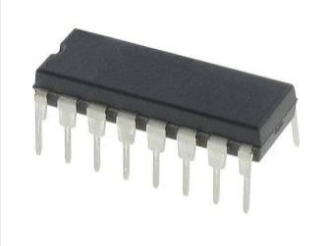

Figure 25: **10bit A/D Converter**

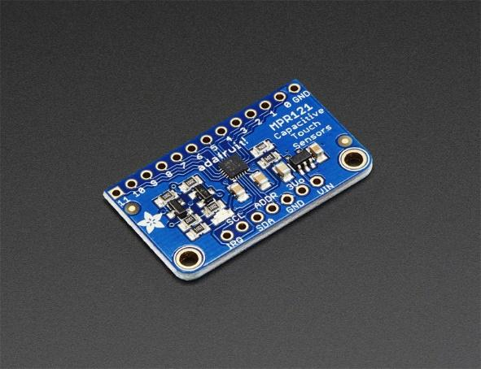

Figure 26: **MPR 121 Capacitive Touch Sensor**

The MPR121 Capacitive Touch Sensor was evaluated to function with conductive materials. Because of this, some leeway was allowed for selection of conductive materials.

Two conductive materials are compared according to the system requirements below:

Table 14: Pressure Sensor Touch Ground Material Selection Matrix

|  |  |  |
| --- | --- | --- |
|  | Aluminum Sheet | Conductive Fabric |
| Resizable | 1 | 1 |
| Cost | 0 | 0 |
| Durable | 1 | 1 |
| Flat | 0 | 1 |
| Ductility | 0 | 1 |
| **Total Point** | **2** | **4** |

Both aluminum sheet and conductive fabric are properly conductive and can resized to fit inside the model smart room. The cost of both are almost identical, but the aluminum sheet is easily malleable which could lead unevenness of the floor. Since portability is an important requirement the pressure sensor must include the ability to be folded and stored. This will also lead to the aluminum sheet to become uneven, and fail the requirement. Thus, a conductive fabric is selected for this design.

### 5.5.4 Design

The MPR121 Capacitive Touch Sensor was selected and implemented in the pressure sensor design. The working principle of MPR121 is the amount of charge Q applied is programmable by setting the charge current I, and the charge time T. Once the electrode is charged, the peak voltage V at the end of charge is measured by internal 10bit ADC. This voltage is reverse proportional to the capacitance C on the sensing channel. The following equations display this relationship:

$$C=\frac{Q}{V}=\frac{I*T}{V} V=\frac{I*T}{C},$$

A finger acts just like a capacitor: when it makes contact with the sensor, the voltage will change, and the MPR121 Capacitive Touch Sensor will detect a “touch”.

The new pressure sensor includes a total of 12 configuration zones, with a 3x4 placement design as the figure # illustrates:

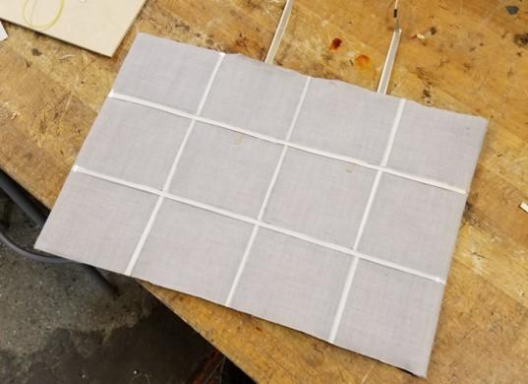

Figure 27: **New Pressure Sensor Design**

An isolation layer is built between each touch zones to ensure proper accuracy of detection. When a single quadrant is touched, a corresponding noise signal will be generated around that zone, which the isolation layer helps to alleviate. A side view of the isolation layer is shown on figure #. Electrical tape and isolation plastic material are implemented for this design:

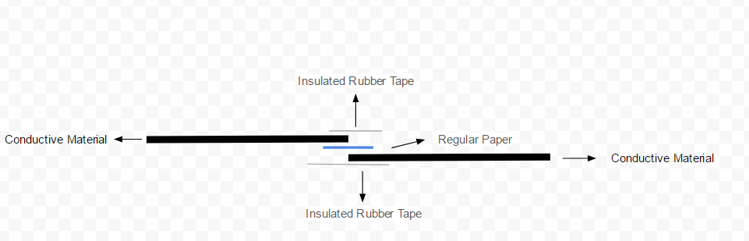

Figure 28: **Side View Diagram of Joint Between Each Touch Zone**

To ensure the pressure ground stays flat, a regular wire is replaced by conductive tape. For the two mid-zone connections, conductive tape will go under the other zones and will be covered by electrical tape to eliminate noise. Figure # shows a side view of the wiring of mid-zones, and the figure # shows the actual test of wiring of mid-zones.

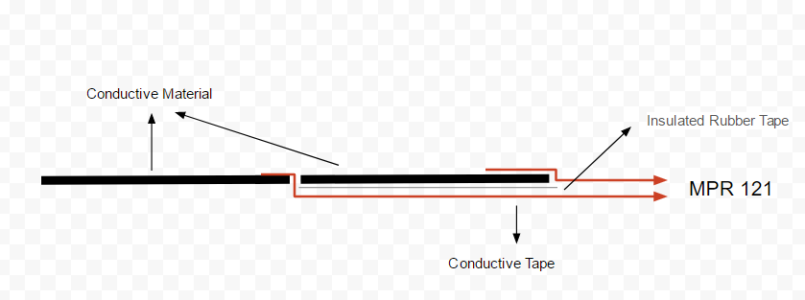

Figure 29: **Side View Diagram of Wiring of Mid-zones**

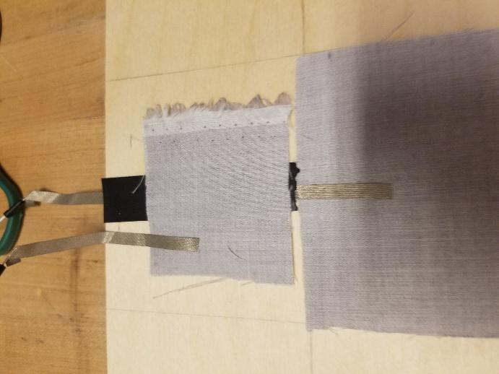

Figure 30: **Actual Test of Wiring of Mid-zones**

### 5.5.5 Subsystem Evaluation

As figure # demonstrates, the conductive fabric utilized by the pressure sensor results in a very flat floor, with zero difference level which meets the requirement sufficiently.

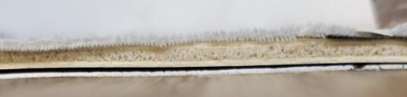

Figure 31: **Side View of New Pressure Sensor**

The final size of the pressure sensor circuit is $${1.5}^{''}x 0.8''$$, with only 12 wires. The figure below demonstrates the circuit of new pressure sensor:

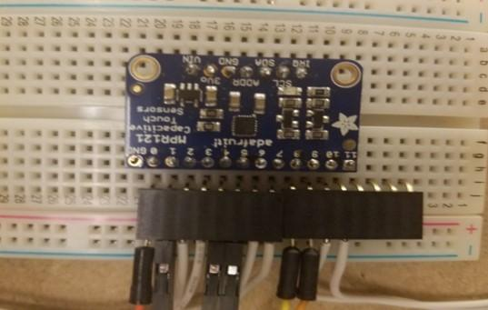

Figure 32: **Top View of Circuit of New Pressure Sensor**

The 3x4 touch zones are isolated from each other very well. All 12 configuration zones have been tested and meet the requirements sufficiently.

Testing was conducted on Arduino and RPi platforms, respectively. The sensor can measure capacitance in objects such as our fingers, although this capacitance is quite small (around 0.01 pf). But when the sensor is touched by other materials such as wood, the corresponding measurement is much too low for any observable voltage change, and thus will not be detected by the sensor.

### 5.5.6 Open Issues

Although the current pressure sensor meets almost all of the requirements sufficiently, there is room for improvement in stability. In the current design, conventional wiring is partially replaced by conductive tape to ensure a flat connection to pressure ground. And when the connection goes out from the box, the conductive tape will connect with regular wire, because conductive tape cannnot connect to the input pin of MPR121 Capacitive Touch Senor directly. Figure # illustrates the joint between conductive tape and regular wire:

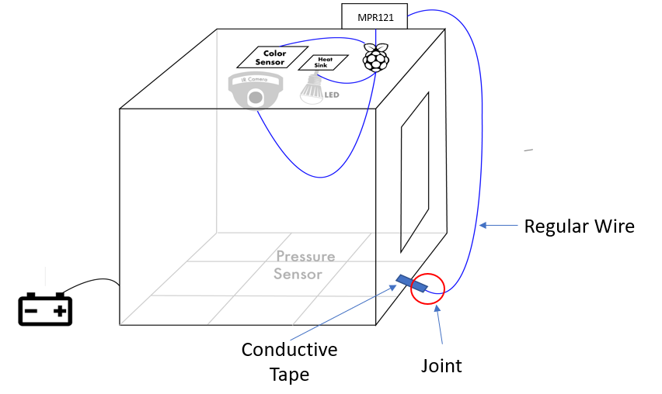

Figure 33: **Diagram of Joint Between Regular Wire and Conductive Tape**

The issue with this is that connection of conductive tape to wires is not stable or reliable. One solution would be to solder the tape to the regular wire. But for the current design, the conductive tape will melt during the soldering process. Figure # demonstrates the melting of the tape:

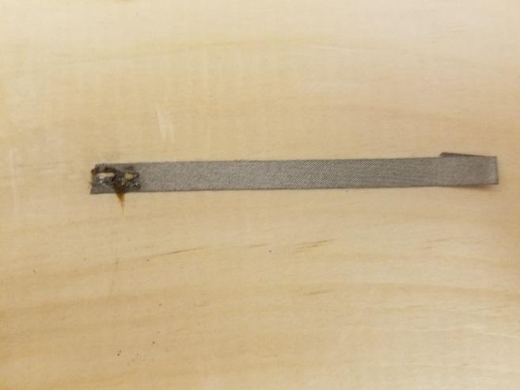

Figure 34: **Melted Conductive Tape**

It is suggested that future teams replace this fabric conductive tape to copper conductive tape. Copper conductive tape can be successfully soldered with wires while retaining a reliable connection. Figure # shows an example of soldering copper conductive tape with a regular wire.

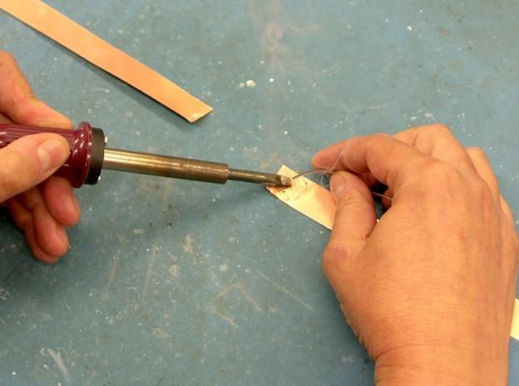

Figure 35: Soldering Copper Conductive Tape with Regular Wire